Erick Cabrera

ITM 311-02

Midterm Practical

October 22, 2016

**Code**

import java.util.Scanner;

//Erick Cabrera, Programmer

public class Inventory

{

static Scanner sc = new Scanner(System.in);

static int sumItems;

static double average;

public static void main(String args[])

{

// begin local variable declaration / initialization zone

char answer = 'Y';

// call a method

displayMenu();

while(answer == 'Y' || answer == 'y')

{

//call methods

averageCost();

computeTax(sumItems, average);

// begin code block to display results

System.out.println("***************************");

// end code block to display results

// begin code block to perform additional program run

System.out.println("run again(Y or N)?");

answer = sc.next().charAt(0);

// end code block to perform additional program run

}

System.out.println("***************************");

}// end main() method

static void displayMenu()

{

// begin program menu

System.out.println("");

System.out.println("");

System.out.println("*******************************");

System.out.println(" Inventory Valuation ");

System.out.println(" (Weighted Average Method) ");

System.out.println("*******************************");

System.out.println("");

System.out.println("");

System.out.println("----------- M E N U -----------");

System.out.println("");

// end program menu

}//end method

static double averageCost()

{

double cost = 0.0, totValue = 0.0;

int number = 0, quantity = 0;

String item = "";

// begin code block for inventory evaluation

System.out.println("number of item types in the inventory ->");

number = sc.nextInt();

for(int i = 1; i <= number; i++)

{

System.out.println("enter the item's description");

item = sc.next();

System.out.println("item description: " + item);

System.out.println("enter item quantity");

quantity = sc.nextInt();

sumItems += quantity;

System.out.println("enter item cost");

cost = sc.nextDouble();

totValue += cost * quantity;

}

average = totValue / sumItems;

System.out.printf("average cost: $%.2f\n", average);

// end code block for inventory evaluation

return average;

}//end method

static void computeTax(int sumItems, double average){

double tax = average * .06;

System.out.printf("at a level of " + sumItems + " units, the inventory tax is $%.2f\n", tax);

}

}// end class

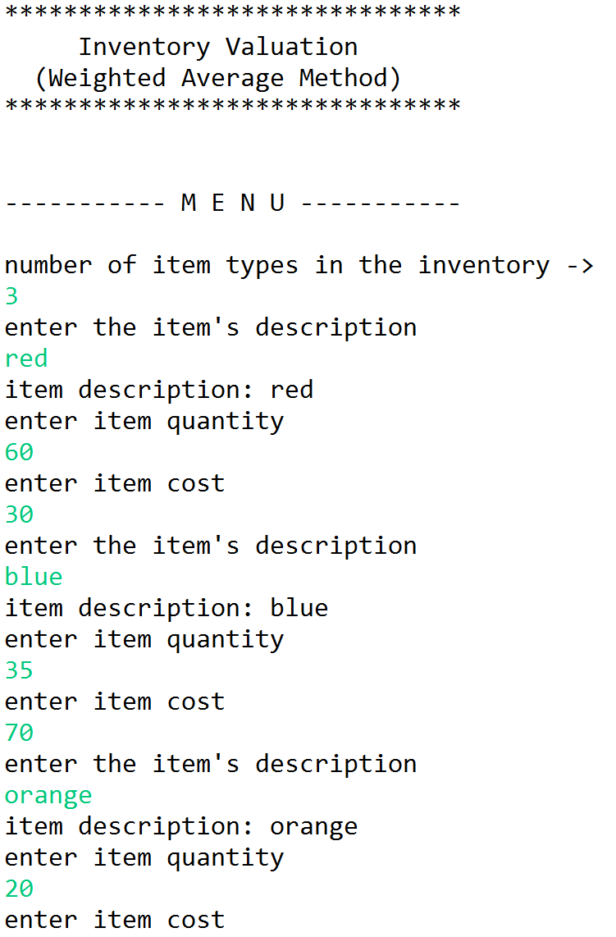**Output**

